

**CSE 414 DATABASE**

**SPRING 2024**

**HOMEWORK 1**

**MERT GÜRŞİMŞİR**

**1901042646**

**DESIGN**

For the building a NoSQL database system for banking operations, I have used MongoDB database technology.

For the banking operations I have 4 collections:

* customers
* accounts
* transactions
* branches

I am keeping accounts’ id values that customers has as an array in the customers collection. Also I am keeping associated customer’s id value in the accounts collection to easily access customer, to know who owns the account. Each customer can have several accounts but each account has only 1 user. I am also keeping branches’ id values in the accounts collection to know which branch each account belongs to. Different accounts can have same branch but an account can have only 1 branch. I am keeping accounts’ id values in the transactions to know that transaction belongs to which account. Accounts can have more than 1 transactions but transactions can have only 1 account.

Advantage of keeping the id values is it reduces the data duplication. We can access the to other collections by using the id values.

In order to visualize the paragraph, I am representing my schema design below:

These schemes provide flexibility and scalability. For example, if a new requirement arises in the future, we can easily add new fields or change the existing structure.

Creating the database:



Creating collections:

**BRANCHES**

Inserting Branches:

I have used insertMany to insert 2 branches at once. I have given fields and values for 2 branches.

**CUSTOMERS**

Inserting a customer:

Here, I am inserting 1 customer with specified fields. I have not given any id value for the customer because it is automatically assigned.

name is an object that keeps first and last values that specify the first name and last name.

email, phone, address fields are all string.

accounts field has an array to keep accounts id values that user has. Initially the array is empty because user doesn’t have any account at the beginning.

Inserting many customers:

**ACCOUNTS**

Inserting a new account for user Mert (for WestSide branch):

Now since a new account is added to customer with ID “662d89e7b2bbeb64b81b0e9e”, we  
 need to add this account to that customer’s accounts field.

Now customer looks like this:

I am keeping accounts as array to be flexible. So when a new account is going to be added   
 to the customer, its id is going to be simply pushed to that array.

Insert 2 accounts for user Haruki Murakami (for WestSide branch):

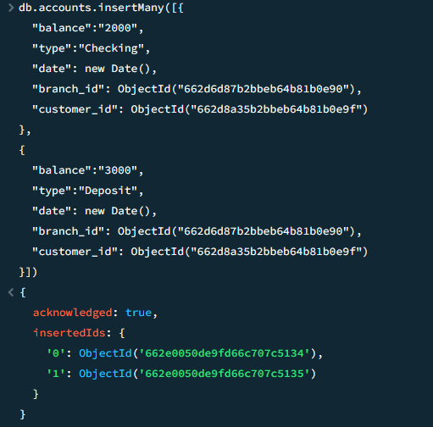

Updating Haruki’s accounts field:

Haruki now looks like this:

Insert an account for user Carl Sagan (for WestSide branch):

Updating Carl’s accounts field:

Carl now looks like this:

Inserting 3 accounts for user Richard Feynman (for EastSide branch):

Updating Richard’s accounts field:

Richard now looks like this:

Inserting 2 accounts for user Nilgün Marmara (for EastSide branch):

Updating Nilgün’s accounts field:

Nilgün now looks like this:

**TRANSACTIONS**

Now user Mert is making transactions:

User Haruki making transactions to his accounts:

User Carl making transactions to his account:

User Richard making transactions to his accounts:

User Nilgün making transactions to her accounts:

I am summing up all the accounts and transactions below:

* **MERT GÜRŞİMŞİR (1 account, 3 transactions)**
  + Account
    - Transactions: +1000, -1000, +1000
* **HARUKI MURAKAMI (2 accounts, 5 transactions)**
  + Account 1
    - Transactions: +2000
  + Account 2
    - Transactions: +3000, -1000, -500, +1500
* **CARL SAGAN (1 account, 7 transactions)**
  + Account
    - Transactions: +2000, -1500, +500, +2000, +1000, -500, +500
* **RICHARD FEYNMAN (3 accounts, 6 transactions)**
  + Account 1
    - Transactions: +1000, +4000
  + Account 2
    - Transactions: +6000
  + Account 3
    - Transactions: +4000, -1000, +4000
* **NİLGÜN MARMARA (2 accounts, 3 transactions)**
  + Account 1
    - Transactions: +4000, +4000
  + Account 2
    - Transactions: +9000

**QUERIES**

1 🡪 Retrieve all transactions associated with a particular account

Haruki Murakami’s transactions associated with his 2nd account:

2 🡪 Find the total balance of a customer across all accounts

Finding total balance of Richard Feynman across all of his accounts. His first account has 5000, second account has 6000, third account has 7000 so in total he has 18000:

Finding total balance of Haruki Murakami across all of his accounts. His first account has 2000, second account has 3000 so in total he has 5000:

With aggregate, we process data records and return computed results. match and group are stages in aggregation pipeline:

1. $match: Filters documents based on specified criteria similar to find() method. Here we are selecting only those accounts associated with the specified customer based on the customer_id.
2. $group: Groups the documents based on specified criteria and applies expressions to the grouped data. Here we are grouping the accounts by customer_id and calculating the total balance.

3 🡪 Identify customers with the highest number of transactions

In the current situation, Carl Sagan has the most number of transactions with 7 transactions.

Query:

Result:

Here we have 7 stages:

1. $lookup: Here we are joining the transactions collection with the accounts collection based on the account_id.
2. $unwind: Here we are deconstructing the resulting array from the $lookup.
3. $lookup: This another lookup is for joining the accounts collection with the customers collection based on the customer’s id.
4. $unwind: This unwing is deconstructing the resulting array from the second $lookup.
5. $group: In this stage, we are grouping transactions by customer and calculating the total number of transactions for each customer.
6. $sort: Here we are sorting the customers based on their total number of transactions in descending order specified by -1.
7. $limit: This is for retrieving only the first result which will be the customer with the maximum number of transactions.

Richard Feynman has 6 transactions. I am adding 2 test transaction for his second account:

Now making the same query I am getting the result:

4 🡪 Get a list of branches along with the total number of accounts associated with each branch

Mert’s 1 account, Haruki’s 2 accounts, Carl’s 1 account are associated with WestSide branch;

Richard’s 3 accounts, Nilgün’s 2 accounts are associated with EastSide branch.

Stages:

1. $lookup: To join accounts collection with the branches collection based on branch_id.
2. $unwind: Deconstructing resulting array from $lookup.
3. $group: Grouping accounts by branch and calculating total number of accounts for each.